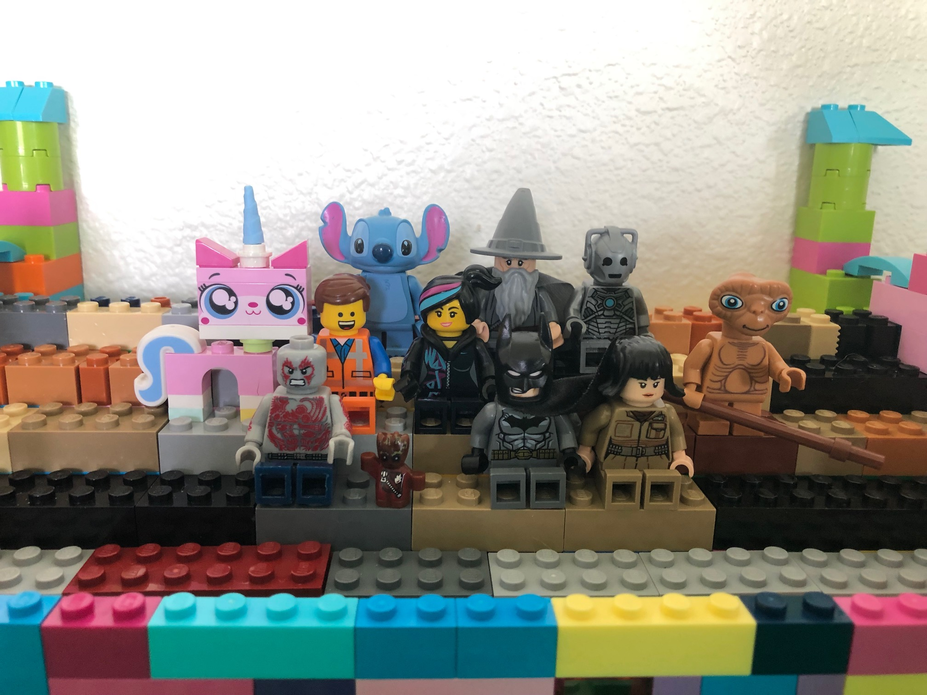

I am Groot.

Who am I?

Know your Audience!